Conduct user interviews.

Now that you’ve learned about finding research participants in the reading Find and recruit interview participants, you’re ready to conduct user interviews!

Remember that for the purposes of this course, conducting these interviews is **optional**. This reading, along with the other optional reading and videos in this lesson, is for those who would like to get early experience conducting real-life interviews, or who simply want to learn more about the UX research interview process.

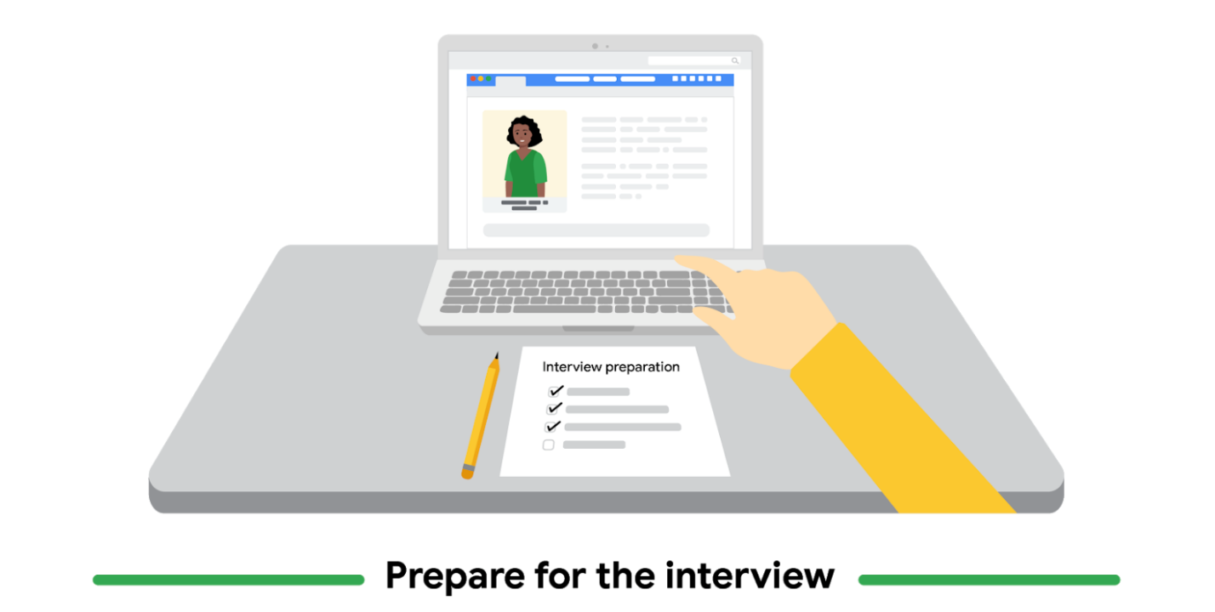

Whether you're conducting interviews in person or online, it’s important to be prepared before you speak with real users. You want to make the most of your limited time together and learn as much as you can about their unique perspectives. Here are a few things you can do to prepare for interviews:

**Script interview questions.** Develop a list of questions that you’ll ask all of the users you interview. It's considered a best practice to keep interview questions fairly consistent across users, but this list of questions is just a guide. You can deviate from the questions you prepared, if necessary, to learn more about the user and their pain points.

**Collect supplies.** Create a checklist of items you'll need for the interview, such as a computer, a printed list of questions, or paper and a pencil. If you're using new equipment or technology during the interview, make sure you know how it works in advance.

**Research the users.** Take time to learn what you can about the people you’ll interview. If the users you’re preparing to interview provide their personal information before the interview, be sure to take note of it. This information might include their name, demographic information, relevant experience with the product you’re designing, or details about how they learned about the interview. You can use this information to extend the conversation during the interview and build a rapport. When you work for an organization, you can also screen participants on sites like LinkedIn to confirm they are who they say they are. You wouldn’t want to accidentally interview someone who is working for the competition!

**Practice.** It’s always a good idea to practice delivering the questions you’ll ask users before you conduct a real interview. This gives you time to make changes to the questions you’re planning to ask and helps ensure that the interviews run smoothly. Practicing is also a good way to determine if the length of the interview is appropriate, or if you need to add or cut questions from your list. You can practice asking interview questions in front of a mirror or with a trusted colleague.

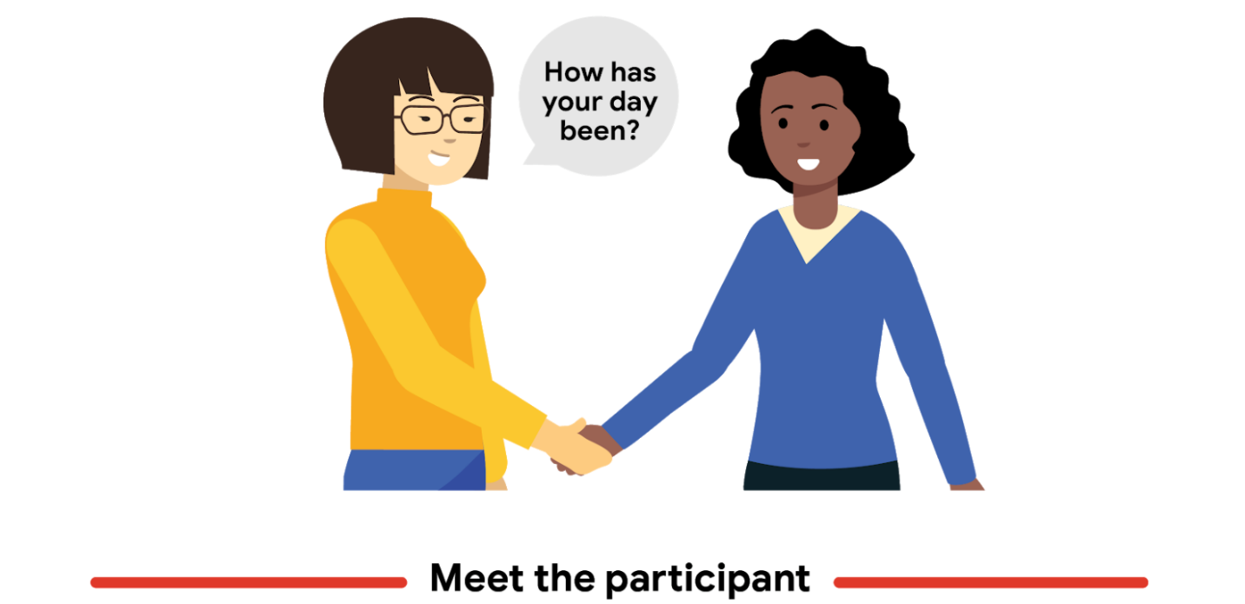

First impressions matter! As you meet users for the first time, at the start of an interview, you want the conversation to be set up for success. Here are a few things you can do when meeting interview participants:

**Build a rapport.** Building a good rapport is all about establishing a professional, but friendly, interaction. Making light conversation, like asking how the user's day has been, can help establish a relationship before the interview begins. Simple questions and welcoming gestures can put the user at ease, which will help them share their true feelings once the interview begins.

**Thank users for coming.** Before the interview begins, show gratitude to the people you’re interviewing for taking the time to meet with you and share their perspectives. Thanking users is a part of establishing a good rapport and can help them feel like their opinions are valued.

**Gather basic details.** As you meet users, remember to ask about basic information that's relevant to the interview, such as their name or demographic details.

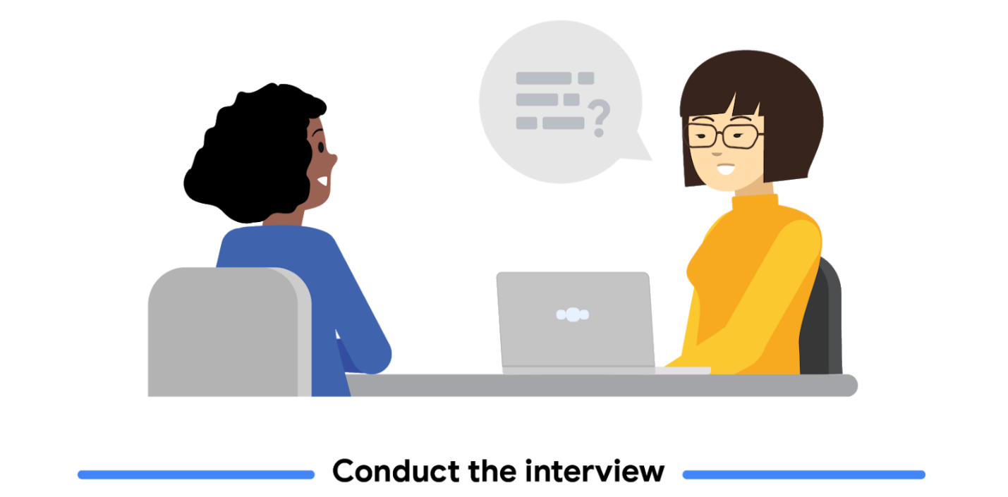

Conducting interviews as a way to empathize with users is all about making the user feel comfortable and asking lots of questions. Here are a couple of things to keep in mind as you conduct interviews:

**Follow interview etiquette.** Speak in a clear and concise manner while asking questions, and remain professional no matter how users answer a question. Show that you are actively listening while users share their perspectives, such as nodding, making appropriate eye contact, or writing notes.

**Ask open-ended questions.** Avoid asking questions that would lead to a simple “yes” or “no” answer. Instead, ask questions that start with “why.” For example, avoid asking "Do you like going to the library?" and instead ask "Why do you like or dislike going to the library?" This will allow for more detailed conversations and can reveal useful information to include in the product you're designing. If the participant does provide a short “yes” or “no” answer, you should ask a follow-up question to get them to share more.

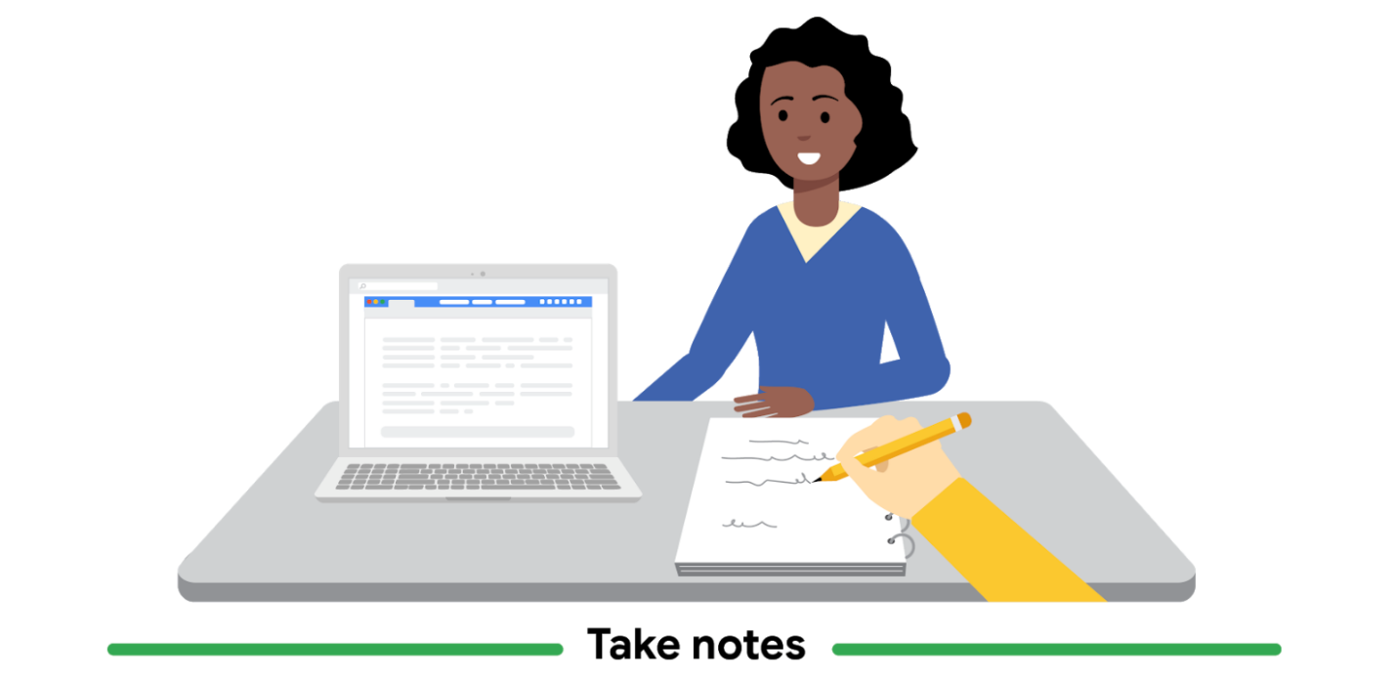

Interviews tend to happen quickly. Without taking notes, recounting exactly what participants expressed can be nearly impossible! As you watch and listen to participants during the interview, write down as much as you can capture. A robust list of notes and observations will be helpful when you come up with ideas to solve users’ pain points. Here are a few best practices to help you take notes during interviews:

**Highlight compelling quotes.** The most obvious part of an interview is to take notes on what the user says. Interesting quotes are strong indicators about how users really think and feel. Including quotes in your empathy maps is a great way to feature a firsthand perspective from a real user, which can provide valuable insight when you begin your designs.

**Document observations about participants.** It's important to record not only what users say, but also their mood, expressions, body language, and behaviors. Pay special attention to outside factors, like a noise or distraction, that might skew interview responses. All of these observations will be important to consider when creating empathy maps.

**Record interviews.** Ask participants if they will allow you to record their interview. If they consent, recorded interviews can be really helpful later, for revisiting parts of an interview that you might not remember or taking additional notes after the interview concludes.

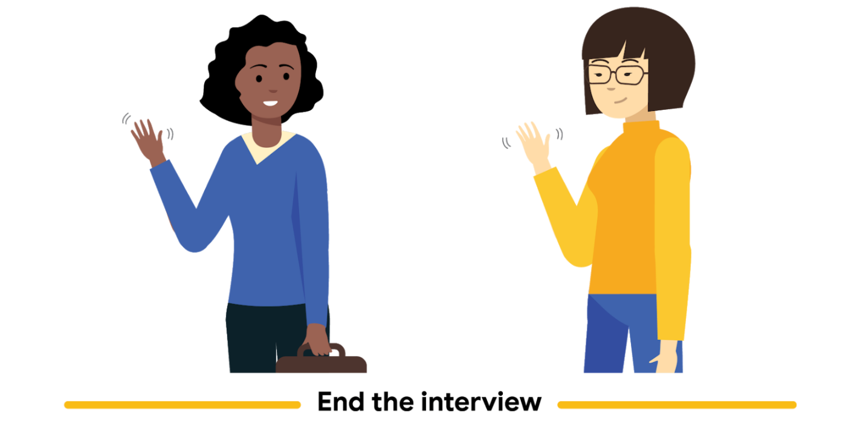

After you've asked all of the interview questions, give users a chance to share their final thoughts about any items discussed during the interview. Some participants might open up about their opinions and reveal insights that they didn’t share earlier.

Also, remember to thank participants once more. You want participants to leave the interview feeling good about you, your future product, and the brand you might be representing.

Activity Exemplar: Build empathy with users to inform your research

Here is a completed exemplar along with an explanation of how the exemplar fulfills the expectations for the previous activity.

To see the completed exemplar for this course item, click the link below and select “Use Template.”

Link to exemplar:  [Empathy exercise notes (Reena)](https://docs.google.com/document/d/1OK2DvlpyblFNgQ902h1HNnTG-0oF87pskG2-8yjrZ2c/edit)

**OR**

If you don’t have a Google account, you can download the exemplar directly from the attachment below.

**[Google UX Design Certificate - Reena empathy exercise [Exemplar]](https://d3c33hcgiwev3.cloudfront.net/t8CFUavbRkCAhVGr23ZAlQ_d5b834388026430b9385c4fca05bdaf1_Google-UX-Design-Certificate---Reena-empathy-exercise-Exemplar-.docx?Expires=1682121600&Signature=Q~H4Fcb-0SxW8Sn7hXq~HSIiQ-oKz~rkF7OKIFauoLLgEYg9mWJAkkXfCeaHTqLiZHRjcGmNPXl2QBlmlrzBRCoE01zZV52FUS6x29rhGICRpEccvMPua9qsnjqoUoB8vqo6YoR~X1am~bGjPnKIoM9GJ6ff8deaj0iYiQReuIQ_&Key-Pair-Id=APKAJLTNE6QMUY6HBC5A" \t "_blank)**

[DOCX File](https://d3c33hcgiwev3.cloudfront.net/t8CFUavbRkCAhVGr23ZAlQ_d5b834388026430b9385c4fca05bdaf1_Google-UX-Design-Certificate---Reena-empathy-exercise-Exemplar-.docx?Expires=1682121600&Signature=Q~H4Fcb-0SxW8Sn7hXq~HSIiQ-oKz~rkF7OKIFauoLLgEYg9mWJAkkXfCeaHTqLiZHRjcGmNPXl2QBlmlrzBRCoE01zZV52FUS6x29rhGICRpEccvMPua9qsnjqoUoB8vqo6YoR~X1am~bGjPnKIoM9GJ6ff8deaj0iYiQReuIQ_&Key-Pair-Id=APKAJLTNE6QMUY6HBC5A" \t "_blank)

Note: You should have completed four empathy exercises using the user bios you selected. This example includes just one interview using one of the example bios provided in the activity. The questions are part of a UX research interview for a mobile food ordering app.



Empathy exercise

**Reena**

**Age:** 37

**Education:** College graduate

**Hometown:** Lakewood, Colorado

**Family:** Lives mostly alone, has a teenage daughter

**Occupation:** Paramedic

Reena is a paramedic who lives in Lakewood, Colorado. Reena lives alone but shares custody of their daughter with their ex-partner. Reena works both day and night shifts, and their schedule changes week to week. They are a rock climber who go to the climbing gym a few mornings a week and also drive their daughter to soccer practice a couple of nights a week. Reena has dyslexia, which makes it difficult to read text quickly and process information in fast-paced settings.Reena is health-conscious and budget-conscious.

**Question 1:** Can you describe your current schedule and how you balance your responsibilities with meal planning?

**Response:**

* Paramedic - busy and often undefined schedule/doesn’t know their schedule weeks in advance
* Climbs at a climbing gym in the mornings
* Takes daughter to soccer practice Tuesday and Thursday nights
* With unpredictable schedule, it can be difficult to coordinate both transportation and meals
* Usually tries to prepare food at home and make healthy meals, but grocery shopping is time consuming so they often resort to takeout or delivery as a faster option

**Question 2:** How often do you order meals from a restaurant? When you do, what is your motivation for doing so?

**Response:**

* Orders takeout or delivery 3-4 times a week/usually for dinner
* Daughter loves ordering out, so they usually do so on Tuesdays and Thursdays after soccer practice
* On particularly busy days, they may prefer to get food delivered rather than pick it up
* Lack of time/energy after working long hours, climbing, and driving to and from soccer practice
* Planning a meal and planning what groceries to buy takes time
* Prefers more affordable options and being able to order enough food for a small family within their budget
* They try to opt for healthy meals
* They typically like to order from places that they can pick up from on the way home, without making a huge detour
* Has some favorite restaurants but likes to mix it up once in a while, if they have time to look for a new restaurant

**Question 3:** What challenges do you face in the ordering process? How does this make you feel?

**Response:**

* Lack of images (it’s hard to read through all the text sometimes, images would be more convenient)
* Hard to scan information, especially on a small phone screen (dyslexia). This might make Reena feel frustrated and even self-conscious about their disability.

**How could the needs, challenges, or concerns of this user be resolved?**

Someone like Reena could benefit from having a screen reader in the app, especially if it’s going to be text-heavy in places. Sites that offer compatibility with screen readers can make the experience more pleasurable and require less effort. If an app can make a user feel included with details like this, it’s probably going to keep the user coming back.

Reena, like many working parents, is clearly very busy and doesn’t have time to spend browsing for the perfect meal every day. They have favorites they like to order frequently, so having a system in the app where users can “favorite” certain restaurants and then find them easily later, would be useful. They also prioritize healthy options and affordable options. Nutrition facts and a tool where users can filter restaurants by price range could be helpful.



In this exemplar, the UX researcher consistently referred to the details provided in Reena’s bio to create a complete image of Reena’s life, making educated guesses about Reena’s pain points and features that would be helpful to them in an app.

Compare the exemplar to your own notes.

* Did you base your mock responses as closely as possible on the information presented in your user bios, including their stage in life, their career and their personal priorities?
* Did you get creative and expand on your interview responses enough to create a clear picture of your user and how you might best serve them with your design?

With those questions in mind, ask yourself what you did well and where you can improve. Use your answers to guide you as you continue to progress through the course.